Line Numbering Using LEX
Aim :
To write a LEX program to read an input file, add line numbers to every line, and display the numbered contents on standard output.

Pseudocode :
BEGIN
Open input.txt
If file cannot be opened
Display error message
STOP
End if

Set yyin to input file
Set line number to 1
Read the file using yylex()
For each line
Display line number and line contents
Increase line number
End for

Close input file
END

Code :

%{
#include <stdio.h>
int line = 1;
%}
%%
.*\n { printf("%d: %s", line++, yytext); }
.+ { printf("%d: %s\n", line++, yytext); }
%%
int yywrap(void)
{
return 1;
}
int main(void)
{
FILE *fp = fopen("input.txt", "r");
if (fp == NULL)
{
printf("Error opening file\n");
return 1;
}
yyin = fp;
yylex();
fclose(fp);
return 0;
}

Output :
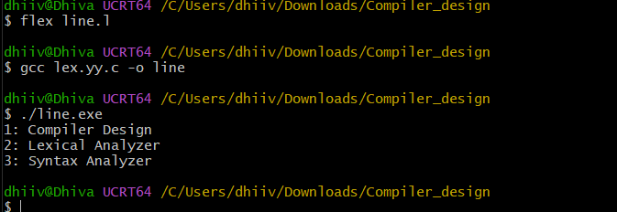

Result :

Thus, the LEX program successfully reads the input file and displays each line with its corresponding line number.

